# **Unemployment: Pakistan vs Bangladesh**

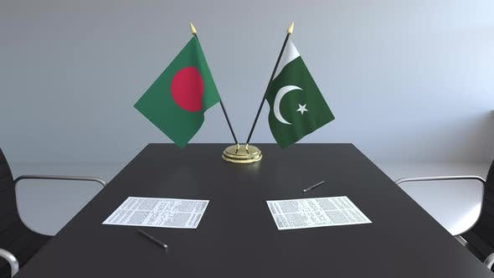

**Muhammad Taha Khan 1747180**

**Murtaza Ahmed Butt 1747185**

**Hamza Sabahat 1747164**

# **ABSTRACT**

In this research we have gathered data for two countries Pakistan and Bangladesh. We aim to analyze the different dynamics of these countries by gathering the data regarding factors such as unemployment, literacy rate, labor force, population growth/decline and the classification of population by gender, the ratio in literacy and unemployment by gender and other variables of the sort, using different sources with authentic data which will represent the statically distributed data of both countries for a clear overview to the reader to identify the pros and cons in each country.

Table of Contents

**Unemployment: Pakistan vs Bangladesh** 1

**ABSTRACT** 2

**Introduction** 4

**GRAPHICAL ANALYSIS** 6

**Results** 17

**Recommendation** 18

**References** 19

# Introduction

Pakistan is a South Asian country. It has a coastline along the Arabian Sea and the Gulf of Oman which borders Afghanistan, China, India and Iran. Pakistan has a diverse geographic environment with the Thar Desert to the east and the Hindu Kush and Pamir Mountains to the north. The system of government is a federal parliamentary republic, the head of state is a head of state of the president, the government is a mixed economy system that combines free market activity and state intervention in Pakistan, and Pakistan is a member of the South Asian Association for regional cooperation (SAARC).

Bangladesh is a South Asian country in the Bay of Bengal, which borders India and all borders except the small border with Myanmar. Bangladesh has flat plains and most of the country lies on the great river deltas of the Himalayas. The system of government is a parliamentary democracy, the head of state is the president and the head of government is the prime minister. Bangladesh has a traditional economic system in which the allocation of available resources is based on heredity and primitive methods. Bangladesh is a member of the Asia-Pacific Trade Agreement (APTA) and the South Asian Association for Regional Cooperation (SAARC).

Unemployment, also called unemployment, occurs when people are unemployed and are actually looking for work. In times of economic downturn, the economy typically faces high unemployment rates. There are many causes, consequences and suggested responses to unemployment.

**Type of unemployment**

* Classic: occurs when the real salary of the profession is above the admissible market level. This means that the number of job seekers is greater than the number of vacancies.
* Cyclical: occurs when the general interest in the economy is insufficient to provide work for all those who have to work. Interest in workers and products decreases, fewer creations and fewer experts are needed.
* Structural: occurs when the labor market is unable to provide work for all those who have to work. There is confusion between the skills of the unemployed and those required for general positions. Unlike constant unemployment, the reason is that unemployment lasts longer.
* Attrition: The length of time between occupations that workers seek or switch between occupations.
* Hidden: The unemployment rate of potential workers that is not taken into account when measuring unemployment due to the way information is collected. For example, if a worker is not looking for work, they can be considered unemployed, so those who have stopped looking for work without a job would no longer think they are unemployed.
* Long term: generally characterized by unemployment lasting more than one year.

# **GRAPHICAL ANALYSIS**



The table above shows the b statistics and dynamics of the population of Pakistan presented by the ratio of literacy rate and the changes that occurred in it throughout the years. The population of Pakistan increased through the year 2013 to 2017 from roughly 191 million people to 207 million people with an approximate growth rate of a little over 2% per annum. The literacy rate in 2013-14 was 48% and remained as such up until after 2017 where the rapid increase was observed and the literacy ratio jumped to 60%.

There are a number of factors that play a role in the literacy of a country. In Pakistan, the literacy rate had been kept exceptionally low due to the occupation of some territories by terrorist groups that had made it impossible for anyone to get any education. It was around this time that, under the rule of Prime Minister Nawaz Sharif and Army Chief General Raheel Shareef, the operation Zarb-e-Azb was launched to hit back at terrorists and regained the lost territories. Although a major setback was faced in the face of the attack on APS Peshawar in December 2014, the drive and desire and hunger for education that had been building up in the Pakistani people for decades was not wavered a little and this statement is supported by the stats displayed in the table that show an increase in literacy as the operation Zarb-e-Azb continually achieved success.



The table above shows the population of Pakistan and its divide based on the unemployment and employment ratio and further divide in terms of Urban and Rural population. The table lists population starting from the year 2009 in which the population is roughly 172.6 million and goes up to 2018 when the population is 206.6 million. Throughout all these years, neatly 70% of the population has fallen within the working age bracket. Out of all those people in the working age bracket, only 33% of the whole population and somewhere between 45 to 46% of the working age population is available to be a part of the labor force. Out of the available 94% labor force there is a whole 6% of the labor force that is unemployed.

From the looks of it a 6% unemployment rate doesn’t seem like a very big deal but in a country with a highly saturated population, market, and little growth, the 6% that constitutes up to about 3.1 million unemployed people sure is a very huge number.

There are several reasons for unemployment and several surveys conducted have shown results that there are certain factors that directly and indirectly affect employment rate in Pakistan. Factors such as GDP growth or inflation have an insignificant or no effect on employment. Population growth, however, plays an important role and directly affects the rate on unemployment in Pakistan. Since there isn’t much industrial growth in Pakistan new jobs cannot be created for the rapid increase in population. This is also a result of lack of FDI. With situation in Pakistan being so unpredictable foreign investors are very hesitant and the savings within Pakistan are already not sufficient to provide a backbone for an Industrial revolution in Pakistan.

In the graphs above that display the literacy rate of Pakistan regionally or provincially through the years we can notice a few things if we study them. The literacy rate throughout Pakistan has remained somewhere near 60% in the past few years. And in that 60% males have mostly dominated the chart. There are several reasons for this.

In our country Pakistan the system is laid out such that only the males in the family are the breadwinners in a very high majority of the cases, with some exceptions. For this purpose, families do not normally feel the need to get their daughters to become educated since they will not be going out with the skills they learned for jobs.

Moreover, a large proportion of the people of the people live below the poverty line, meaning that they struggle even for the basic necessities such as food, water, clothing, shelter and healthcare. Education, for them, is a luxury so unnecessary that they would rather have their child put into child labor to earn another loaf of bread instead of using their young and sharp minds to study and go beyond what they could have imagined at one point.

In the graphs we can notice that the province of KPK has the least to no literacy rate. The blame can be broadly put on terrorism. Many areas of the province had been under the control of terrorist groups who had banned education along with many other things such as western outfits, for example. Their control of these regions lasted for decades and it the newer generations had minimum to no link with education whatsoever. Around 2015-2016, however, we can notice that there are now people in KPK who are now receiving an education, and there are females among them as well. It became possible due to the countless efforts and many sacrifices by the military and the cooperation of the tribal people that the war against terrorism was won by the Pakistan army and after long decades, the situation is now getting back to normal and people are living better lives.

However, what we think the saddest part about this study is the standard at which literacy is defined. In developed countries literacy is defined as people who have graduated school/college/university etc. In Pakistan, however, the standard that defines literacy cannot be set so high. There have been a number of changes in the standard defining literacy in the history of Pakistan but the most heartbreaking ones include calling a person literate if they are able to write their name or able to do their signature.

As per the data collected, the population of Bangladesh in 2019 is less then what was Pakistan’s population in 2009, whereas during the period of 2009-2019 the population of Bangladesh has grown 1.12% on an average per annum. The reason for the slow population growth compared with Pakistan is that there is more consistent family planning and awareness in Bangladesh as compared to Pakistan.

Bangladesh used the unique preventive measures proposed by Malthus and Mir to reduce population growth in Bangladesh by about 67% between 1979 and 2017. Bangladesh suffers from environmental degradation, loss of arable land, loss of biodiversity of agricultural land and deforestation.

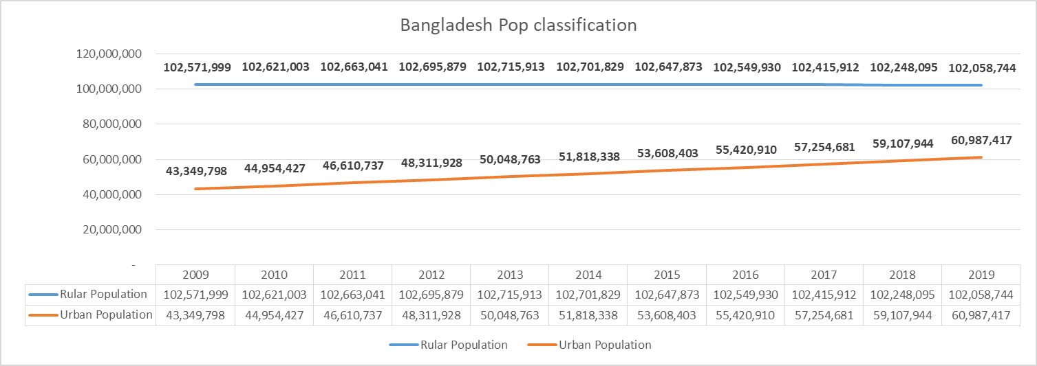

The classification on Bangladesh population shows that the population in rural areas have been pretty much consistent over the time period of 2009-2019 because agriculture is second most contributing factor in Bangladesh’s GDP, The rural population pretty much is engaged in the cultivation of agriculture, however the urban population in Bangladesh has grown 3.7% on average each year over the time period of 2009-2019, this is due to proper family planning, financial stability, access to better lifestyle in urban areas etc, The people in urban population are mostly engaged in the service sector which is the largest source and contributor of Bangladesh.

The labor force in Bangladesh is pretty much near to what Pakistan’s labor force despite having less population then Pakistan, the most prominent reason identified could be as most of Pakistan’s population consist on youth, The high labor and effective labor force of Bangladesh has helped in achieving very high or almost more than double of Pakistan’s growth rate, in 2019 Bangladesh’s growth rate 8.2% which is considered really good compared with Pakistan’s growth rate of 1% in 2019, however the unemployment is rate in Bangladesh on an average is -0.89% which means that over the time span of 2009-2019 the unemployment has decreased 0.89 each year due to consistent and improved growth rate achieved by Bangladesh over the years.

The definition of literacy in Bangladesh is age 15 and over can read and write, as per the sources CIA world factbook, the literate population in Bangladesh in 2020 is 73.9% overall, comparing it with it with 53.7% in 2011, there is a massive change of 37.61% change since 2011-2020, moreover this is due to better quality of education, good environment I government schools, educated teachers and literate family background. As indicated by UIS, the government multiplied consumption in the education sector to more than $4.3 billion of every 2016 from just shy of $2 billion out of 2008. The monetary designation for the training area in the spending plan for the 2017-18 monetary year was more than $7.8 billion. As indicated by the Education Ministry, the public authority has been carrying out various undertakings since 2009, fully intent on developing talented and able HR. The undertakings for the most part rotate around setting out open doors for enrolment at all degrees of training. The public authority has additionally pre-arranged the National Education Policy 2010 to guarantee the privilege to schooling for all. Furthermore, strategy has underlined on guaranteeing essential assets for training, digitization of homerooms and course books, educational plan changes, presentation of innovative inquiry papers, foundation improvement, and the modernization of madrasa instruction. As a feature of this turn of events, the "Sheik Russel Digital Lab and Multimedia Classroom" has effectively been set up at more than 37,000 instructive establishments across Bangladesh. Moreover, in excess of 26,000 elementary schools have so far been nationalized, in a bid to set up a public grade school in each town of the country. At the optional level, Upazila ICT Training and Resource Centers have been set up and 295 non-government schools have been changed into model schools in 315 upazilas. Development of new structures for 5,500 non-government instructive organizations, including schools and universities, is additionally progressing. Overall, the public authority circulates 354.6 million reading material to understudies in Bangladesh consistently.

A study estimates that economic growth, inflation, industry, age dependency rate and urban population growth are the determinants of unemployment. Although inflation is inversely proportional to unemployment, it is not an important variable. However, the negative correlation confirms the Phillips curve in Bangladesh. The study also found that the sector's impact on unemployment is negligible. The relationship between urban population growth and unemployment is negligible. In Bangladesh, only the age rate is an important variable explaining unemployment. As we have seen, labor force participation has increased over the course of the year, but job opportunities have not increased, allowing the country to accept all workers. Extra work. So the focus is on job creation. Most of our workforce works in agriculture, where the workforce suffers from disguised unemployment and underemployment. A further increase in agricultural employment will further reduce labor productivity. The scarcity of land prevents agriculture from hiring more workers.

# **Results**

As per the statistical data covered in excel file and graphical analysis, we can say by looking at the results that Bangladesh is doing far better in terms of Pakistan considering the variable unemployment and other independent variables such as population, literacy and so on, The reason identified of Pakistan being behind Bangladesh is high population growth, poor quality of education, low literacy rate, high growth of population in rural areas, external factors such as terrorism and not allowing female education in most rural areas. These factors have played a major role in holding the growth of Pakistan and providing high underemployed labor force, moreover the structural flaws identified by government includes, poor budget allocation on education, poor infrastructure of government schools and expensive education provided by private education sector, poor quality of education, poor quality of teachers, no presence of teachers in schools, no job opportunities, poor minimum wage rate and so on.

# **Recommendation**

Other indicators are amazing as well. The population of East Pakistan in the 1951 census was 42Million while that of West Pakistan was 33.7 million. But today Bangladesh has far fewer people than Pakistan - 165 m versus 200 m. A sustainable population planning campaign has contributed to the reduction Fertility in Bangladesh. No such campaign - or even its launch - is visible in today Pakistan.

The health sector is not so good far fewer new born die at their birth in Bangladesh than Pakistan. Vaccinations are common and no one is shot for giving polio drops. Life expectancy (72.5 years) is higher than that of Pakistan (66.5 years). According to the ILO Women are way ahead of employment (33.2%) than in Pakistan (25.1%). Put simply, Bangladesh and Pakistan are completely different nations today because they see their, National interest in a very different way. Bangladesh sees its future in human development and Economic growth. Goals to increase exports, reduce unemployment and improve Health, reducing reliance on credit and aid and expanding water and microcredit Border disputes with India are serious and Bangladesh is suffering the greatest harassment Neighbors on illegal immigration, drugs, etc. But its core priorities have not wavered.

The population growth in Bangladesh is 0.98% in 2019, in Pakistan 2.07% Bangladesh has 18.1 births / 1,000 people while Pakistan has 27.4 births / 1,000 people. Pakistan is one of the developing countries where population growth is quite high. For now it is the sixth most populous country in the world with an expected population of 188 million. According to the 2013 World Population Data Sheet, Pakistan will have a population of 363 million in 2050 should keep the same position (i.e. the sixth position). The rate of population growth in at 1.95%, Pakistan is above the average growth rate of the South Asian countries. The main cause of the higher growth rate is the high fertility rate. Although they vary over time Governments of different countries have tried to solve the problem of high population growth in the following ways: Introduce different programs, e.g. B. the Family Welfare Center (FWC) and reproductive health Service Center (RHS-A), regional training institute and mobile service department. However, these programs did not achieve the expected results, mainly due to their low literacy levels. Especially with women in rural areas, cultural and religious restrictions and a lack of skills Promote family planning. It is worth remembering that women's education plays an important role about fertility. Women with higher education have fewer children than women with less education

Education. Therefore, the population increases every year and Due to the growing imbalance of the population, the country's territory is limited. But this population with the help of the country's young population, the imbalance can be improved. Pakistan is one of them the country with the fastest growing youth in the world, with 48% of the population aged 15 to 49 and 56% of the population (15-64 years) belongs to the production age group. That young and energetic the population is seen as a sign of prosperity. You can contribute to the economy your education and skills. Get proper education and training and maintain a balanced health Institutions can prove to be a country's wealth and a source of future prosperity and the development of the country, moreover many of the educational projects have started in Pakistan as per the sources UNESCO and the Government of Pakistan have officially launched a three-year Girls’ Right to Education Programme in Pakistan to support better access to quality education and skills for girls in remote areas of the country, The prime minster educational portal in which different financial and IT courses like SAPS and python are being taught free of cost to provide access to those people who cannot afford such expensive education, moreover to cater with unemployment many of new opportunities are being created in Pakistan in textile industry, Automobile industry, recently MG motors have established their manufacturing plant which is going to provide a lot of job opportunities, furthermore it is confirmed Vox-vegan is also establishing its manufacturing facility in Pakistan by the end of 2022. As per the Pakistan government youth initiatives department, they have realized their future plans to accommodate the coming youth through the stream of education and job opportunities.

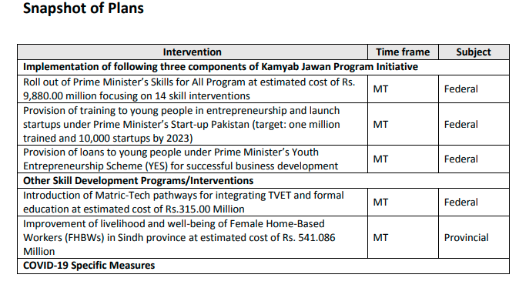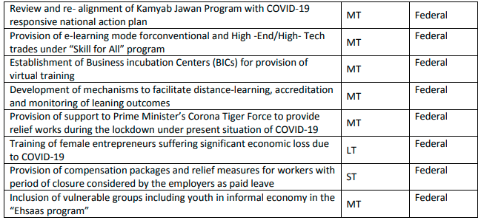

# **References**

<http://dspace.uiu.ac.bd/bitstream/handle/52243/468/Thesis%20on%20Determinants%20of%20Unemployment%20in%20Bangladesh.pdf?sequence=1&isAllowed>

<https://mpra.ub.uni-muenchen.de/32381/1/The_Trends_of_Labor_Market_in_Bangladesh_and_Its_determinants.pdf>

<https://bea-bd.org/site/images/pdf/010.pdf>

<https://www.indexmundi.com/bangladesh/literacy.html#:~:text=Factbook%20%3E%20Countries%20%3E%20Bangladesh%20%3E%20Demographics,total%20population%3A%2073.9%25>

<https://www.dhakatribune.com/bangladesh/education/2018/03/21/unesco-bangladesh-literacy-rate-reaches-time-high-72-76-2016>

<https://www.technologytimes.pk/2019/03/02/unemployment-pakistan/>

<https://mpra.ub.uni-muenchen.de/79210/1/MPRA_paper_79210.pdf>

<https://www.dawn.com/news/1462757>

<https://ijbssnet.com/journals/Vol_5_No_3_March_2014/26.pdf>

<http://www.finance.gov.pk/survey/chapter_10/16_population.pdf>

<https://www.researchgate.net/publication/261285461_Determinants_of_Unemployment_in_Pakistan>

<https://www.worldbank.org/en/home>

<https://www.statista.com/>

<https://www.pbs.gov.pk/>

<http://www.bbs.gov.bd/>

<https://en.unesco.org/news/right-education-programme-launched-pakistan-aims-get-50000-more-girls-remote-areas-school>

<https://www.pc.gov.pk/uploads/youth/Youth_Initiatives.pdf>